MATHS
CLASS- VII
Topic: Integers and Rational Numbers
1. Arrange the following in ascending order.
(a) 30, -2, 0, -6, -20, 8
(b) -99, 54, -89, 70, -3, 2

2. Find the value of the following:
(a) (-5+ 8)
(b) (13-5) ÷ (- 2)
(c) (-3)× (-7)
(d) (-8-6)÷ (-2)

3. Evaluate the following:
(a) 23+(5) – 18+17+ (-11) - (-2)
(b) (-3)×(-17)×(-10)
(c) 15÷ [(-4) +3]

4. Find the product of the following using distributive property:
(a) 138×199 + 138×1
(b) 2358× 999 + 2358×1

5. The product of two integers is -875. If one of them is 25, find the other.

6. What is the difference in height between a point 380m above sea level and 100m below sea level?

7. What number should be added to -23 to get 16?

8. What number should be subtracted from -85 to get -23?

9. An air conditioner cools the room at the rate of 5⁰ C per hour. What would be the final temperature of the room after 6 hours, if the initial temperature of the room is 40⁰C?

10. Find the sum of the following:
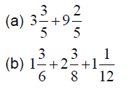
11. Find the difference of the following:
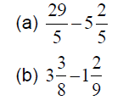
12. Simplify the following:
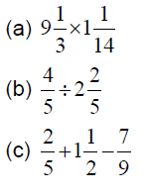
13. A drum full of rice weighs $\frac{241}{6}$ kg . If the empty drum weighs $\frac{55}{4}$ kg, find the weight of rice in the drum.
14. A city received $\frac{5}{12}$ cm rainfall on Sunday and $\frac{16}{3}$ cm rainfall on Monday. How much rainfall did it receive in two days?

PROJECT WORK AND ACTIVITY
CLASS- VII

TOPIC NO 1: Properties of Triangles
TITLE OF THE PROJECT: Classification of triangles based on sides and angles
OBJECTIVE: Identification of type of triangles based on sides and angles.
Material used:
Procedure: Preparing different triangle models based on sides and angles.
Recording Data:
- Based on sides (b) Based on angles

TITLE OF THE ACTIVITY: Depict your final exam marks of class 7th( obtained in different subjects ) on a bar graph
OBJECTIVE : The students will be able to understand more on statistics which deals with analysing the data and drawing inferences from the nume rical information , They will learn pictorial representation of numerical data in the form of bars (or columns) of uniform width and various heights .
Material Required: Your annual marksheet for previous class, textbook, references from internet and related books.
PROCEDURE: In order to draw the bar graph, take subject on x-axis and Y-axis would represent marks obtained.

