Class: 8 Subject: Mathematics Ch- Rational Numbers SSICS, Mohali Date:_____________
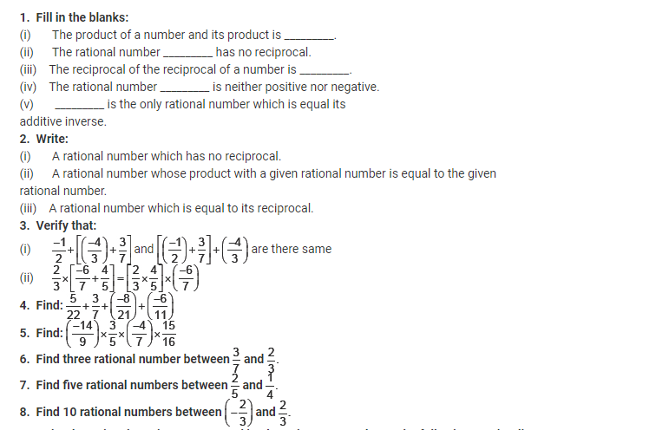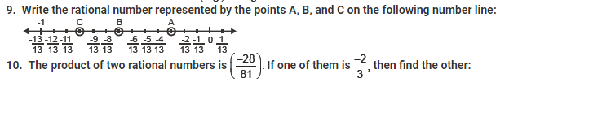
11. How many reciprocals does zero have?
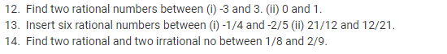
15. Represent the following rational numbers on the number line. (i) � 3/10 (ii) 8/7 (iii) 1.345 (iv)21/7

